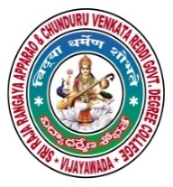 | SRR & CVR GOVERNMENT DEGREE COLLEGE  (AUTONOMOUS)  VIJAYAWADA, KRISHAN DIST., A.P  NAAC B+GRADE(CGPA:2.60) | 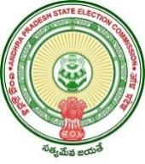

Valmiki Jayanti
Date: 20-10-2021
- Valmiki Jayanti was celebrated by the Telugu Department in SRR & CVR GDC(A) VJA.
- Resource person: Dr.Y.Srilatha Head of the Telugu department and Dr .K.R.G.Seshu Kumar and lecturers.
- Chief Patron: Dr.K.Bhagya Lakshmi.
On this occasion, the principal, Dr.k.Bhagya lakshmi spoke about the greatness of epic poem Ramayana, written by Valmiki. She shares valuable messages from Truth and life style in this epic. The Telugu HOD Dr.Y. Srilatha , staff club secretary Dr.K. R.G. Seshu Kumar spoke about valmiki’s poetry books and how he served society in his life.

